

**Semester Two**

**Examination 2017**

**Question/Answer booklet**

**MATHEMATICS**

**METHODS UNIT 1 and 2**

**Section One:**

**Calculator-free**

|  |
| --- |
| Student Name: _____________________________________ |
| Teacher’s Name: _____________________________________ |
|  |

**Time allowed for this section**

Reading time before commencing work: five minutes

Working time for paper: fifty minutes

**Material required/recommended for this section**

**To be provided by the supervisor**

This Question/Answer booklet

Formula Sheet

**To be provided by the candidate**

Standard items: pens (blue/black preferred), pencils (including coloured), sharpener, correction tape/fluid, erasers, ruler, highlighters

Special Items: nil

**Important note to candidates**

No other items may be taken into the examination room. It is **your** responsibility to ensure that you do not have any unauthorised notes or other items of a non-personal nature in the examination room. If you have any unauthorised material with you, hand it to the supervisor **before** reading any further.

**Structure of this paper**

|  |  |  |  |  |  |
| --- | --- | --- | --- | --- | --- |
|  | Number of questions available | Number of questions to be attempted | Working time (minutes) | Marks available | Percentage of exam |
| **Section One**  **Calculator—free** | **9** | **9** | **50** | **50** | **35** |
| Section Two  Calculator—assumed | 14 | 14 | 100 | 100 | 65 |
|  | | | |  | 100 |

**Instructions to candidates**

1. The rules for the conduct of Western Australian external examinations are detailed in the

*Year 12 Information Handbook 2017.* Sitting this examination implies that you agree to abide by these rules.

1. Answer the questions according to the following instructions.

**Show all your working clearly.** Your working should be in sufficient detail to allow your

answers to be checked readily and for marks to be awarded for reasoning. Incorrect answers given without supporting reasoning cannot be allocated any marks. For any question or part question worth more than two marks, valid working or justification is required to receive full marks. If you repeat an answer to any question, ensure that you cancel the answer you do not wish to have marked.

It is recommended that you **do not use pencil**, except in diagrams.

1. You must be careful to confine your responses to the specific questions asked and to follow any instructions that are specific to a particular question.
2. Spare pages are included at the end of this booklet. They can be used for planning your responses and/or as additional space if required to continue an answer.

* Planning: If you use the spare pages for planning, indicate this clearly at the top of the page.
* Continuing an answer: If you need to use the space to continue an answer, indicate in the original answer space where the answer is continued, i.e. give the page number. Fill in the number of the question that you are continuing to answer at the top of the page.

1. The Formula Sheet is **not** handed in with your Question/Answer Booklet.

# Section One: Calculator–free 35% (50 marks)

This section has **nine (9)** questions. Attempt **all** questions. Write your answers in the spaces provided.

Spare pages are included at the end of this booklet. They can be used for planning your responses and/or as additional space if required to continue an answer.

* Planning: If you use the spare pages for planning, indicate this clearly at the top of the page.
* Continuing an answer: If you need to use the space to continue an answer, indicate in the original answer space where the answer is continued, i.e. give the page number. Fill in the number of the question(s) that you are continuing to answer at the top of the page.

Working time: 50 minutes

**Question 1 (2 marks)**

Find the equation of the circle which has a diameter with endpoints at 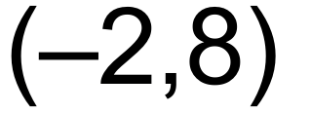 and 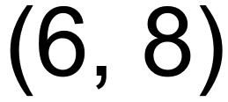.

(2 marks)

**Question 2 (4 marks)**

**(a)** Solve 2sin 2x = 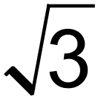 for x where 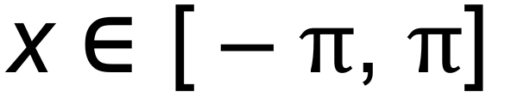. (3 marks)

**(b)** Explain why cos x = 1.2 has no real solution. (1 mark)

**Question 3 (7 marks)**

Determine 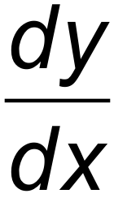 for each of the following.

**(a)** 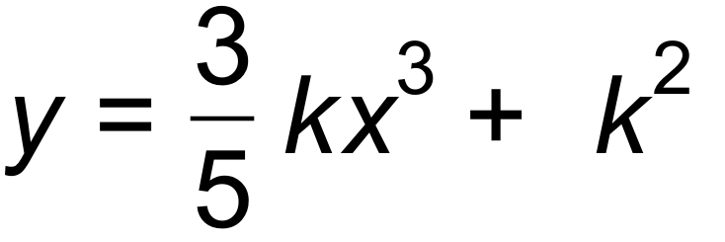 where  is a constant (2 marks)

**(b)** 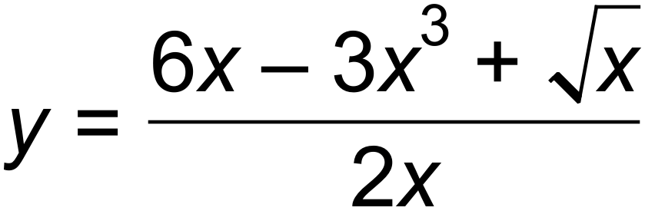 (3 marks)

**(c)**  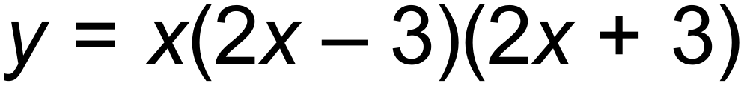 (2 marks)

**Question 4 (4 marks)**

Match each function to its graph below:

|  |  |  |  |
| --- | --- | --- | --- |
|  |  |  |  |
|  |  |  |  |

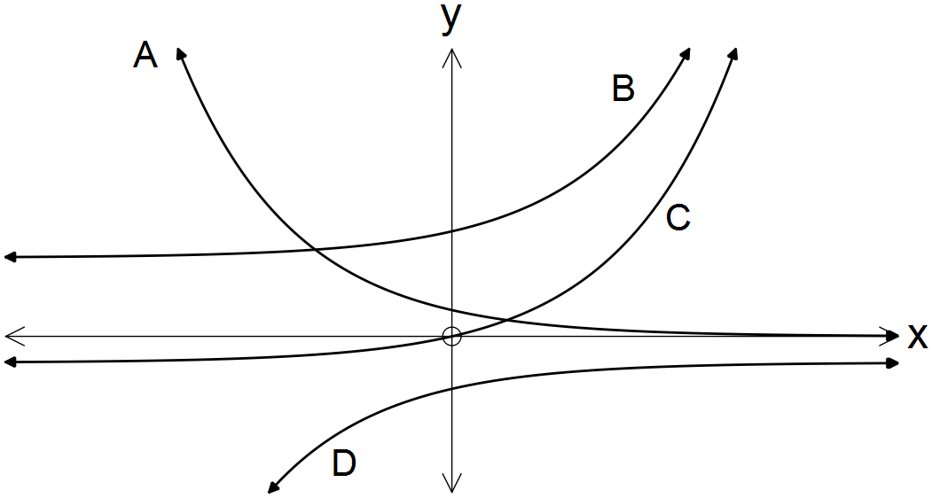

**Question 5 (11 marks)**

**(a)** Simplify the following.

**(i)** 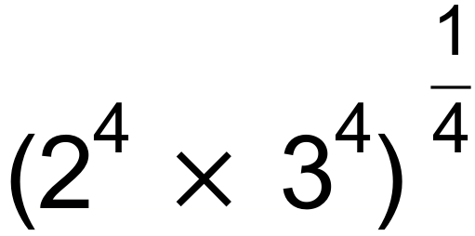 (1 mark)

**(ii)** 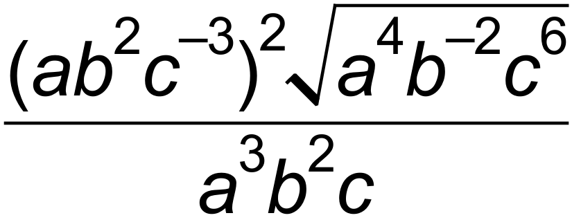 (2 marks)

**(iii)** 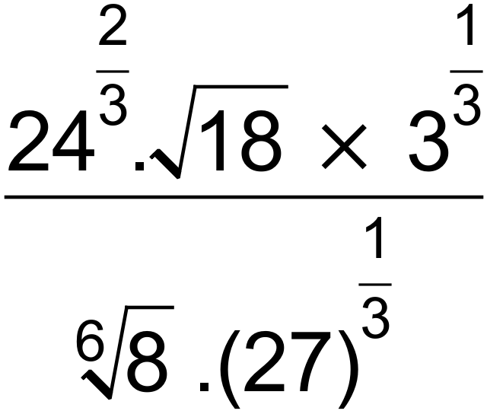 (3 marks)

**(b)** Solve for x. (3 marks)

**(i)** 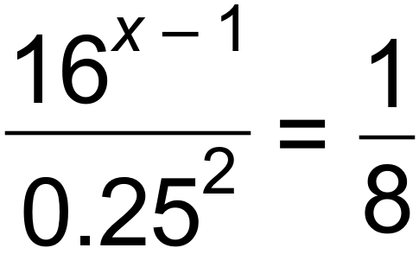

**(ii)** 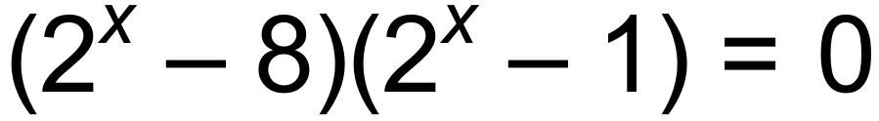 (2 marks)

**Question 6 (5 marks)**

**(a)** G and H are independent events. Given that 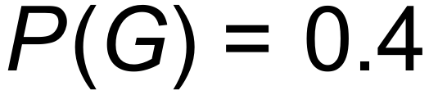 and 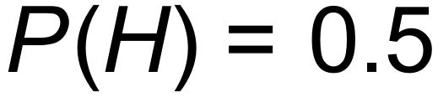, find;

**(i)** 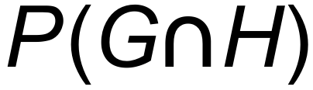 (1 mark)

**(ii)** 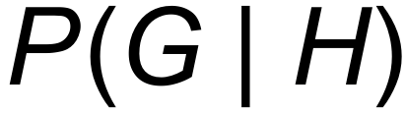 (1 mark)

**(iii)** 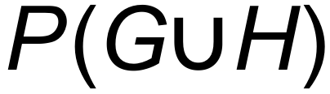 (1 mark)

**(b)** In the expansion of 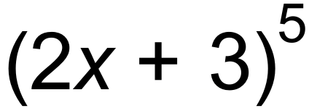, state the coefficient of 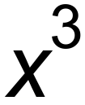. (2 marks)

**Question 7 (8 marks)**

**(a)** Determine the antiderivative of the following. Leave your answers with positive indices where necessary.

**(i)** 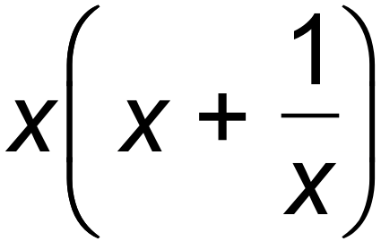 where 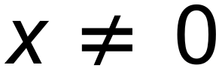 (2 marks)

**(ii)** 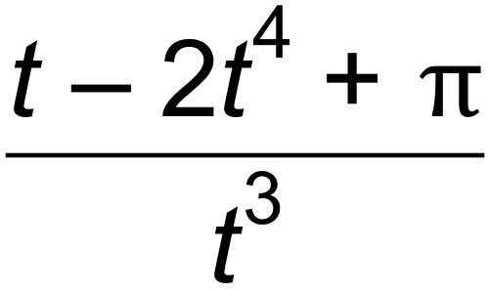 (3 marks)

**(b)** Find 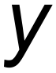 in terms of  for 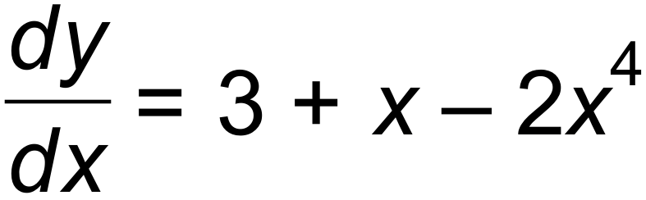, and 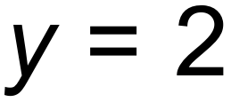 when 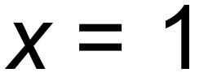. (3 marks)

**Question 8 (6 marks)**

The function 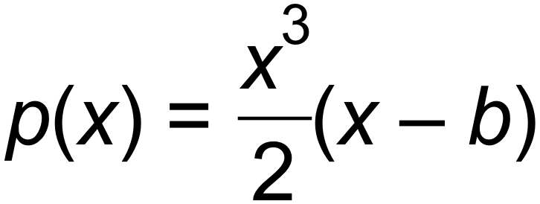 is shown below.

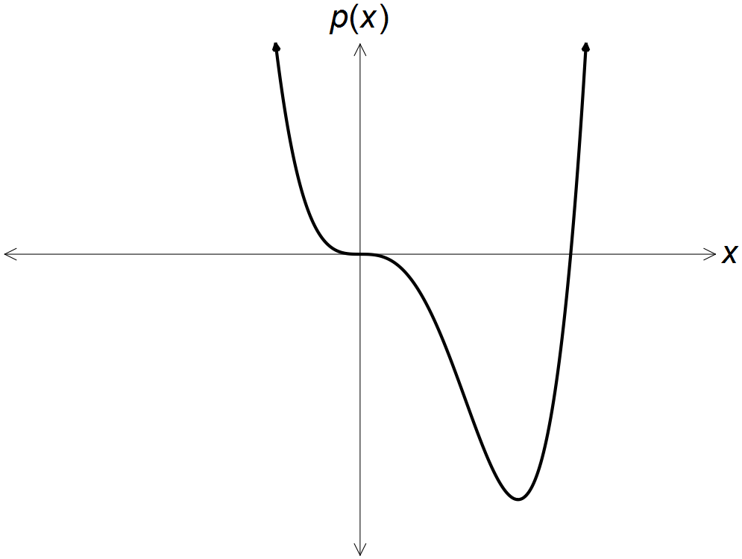

**(a)** Given 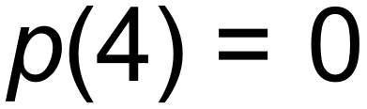, show that *b* = 4. (1 mark)

**(b)** Find the co-ordinates of the local minimum. (3 marks)

**(c)** Show that there is a horizontal point of inflection at 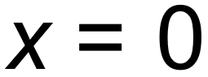. (2 marks)

**Question 9 (3 marks)**

**(a)** State the first three terms of the recursive sequence defined as an = an-1 + n +1, a1 = 3.

(2 marks)

**(b)** State the recursive rule for the following sequence.

1, 1, 2, 3, 5, 8, 13, 21… (1 mark)

**End of Questions**

**Additional working space**

Question number(s): ……………………

**Additional working space**

Question number(s): ……………………